Announcing a new compilation of essays celebrating community education and the praxis of participatory literacy

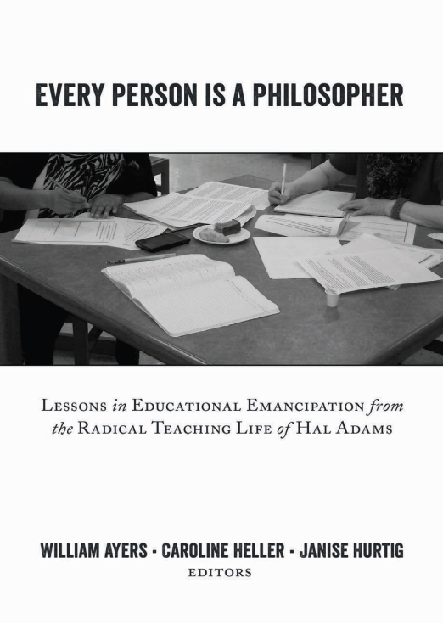
Hal Adams was a radical educator who organized writing workshops for people written off during much of their lives, marginalized by the powerful and the mainstream. Fostering communities of local writers and publishing their work in journals of “ordinary thought,” the work carried the wisdom of their narratives into and well beyond their home communities. In the revolutionary traditions of Paulo Freire, Antonio Gramsci, and C.L.R. James, Hal Adams based his approach on the conviction that every person is a philosopher, an artist, and a storyteller, and that only the insights and imaginings of the oppressed and exploited themselves can sow the seeds of authentic social change.
Every Person Is a Philosopher gathers essays by classroom and community educators deeply influenced by Hal’s educational work and vision. They explore diverse ways in which this humanizing pedagogy can be applied in a wide range of contexts, and consider its potential to transform the lives of students and teachers alike. The collection also includes Hal Adams’ own written reflections.
This wonderfully humane and instructive book pays tribute to Hal Adams, a community educator with a deep belief in the ability of common folk, and also pays tribute--beautiful tribute--to the writers themselves, poor people of color who arise from these pages in their eloquence and agency. -- Mike Rose, author of Back to School: Why Everyone Deserves a Second Chance at Education

Contents: Bill Ayers/Caroline Heller/Janise Hurtig: Introduction: Hal Adams’ pedagogy of ordinary thought: Planting the seeds of change – Hal Adams: A grassroots think-tank: Linking writing and community-building – Elsa Auerbach with Jorge Garcia, Brenda Gonzales, Rebecca Kilgallon, Tamzin Partridge, and Ann Rettman: Ordinary thoughts, whispers of revolutionary thinking – Janise Hurtig: The praxis of sharing and the dialectics of small group writing – Stephen Mogge/ Kate Power: Showing up: Writing, reading and cross-cultural awareness in community literacy work – Caroline Heller: Evidence of things unseen – Christine Tarkowski: Itinerary with Hal – Anne Carlson/Michael Staudenmaier: Philosophers in La Casita: Hal Adams’ politics in theory and practice – Janet Isserlis: Listen to me, listen to us: lives made better – Peter Kahn: Making the ordinary extraordinary: Youth writing, publishing and performing poetry – Annie Knepler: Goldfish in the river: Stories capturing moments in time – Hal Adams: Writing and changing together: Reflections on writing workshops in Chicago neighborhoods.

PUBLISHED BY PETER LANG PRESS -- 2016
You can find additional information and order the book at:
http://www.peterlang.com/index.cfm?event=cmp.ccc.seitenstruktur.detailseiten&seitentyp=produkt&pk=84910&cid=533&concordeid=312937

